**Adagio – Order Entry (redo an Invoice to a Customer)**

* Open ORDER ENTRY Module
* Order Entry 🡪 Day End Processing

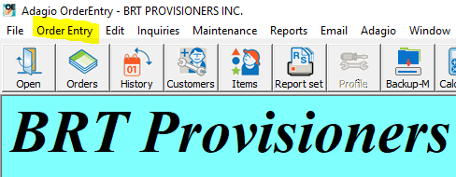

* Check the box for “Print Invoice/Credit Note audit list”
* Click DAY END button

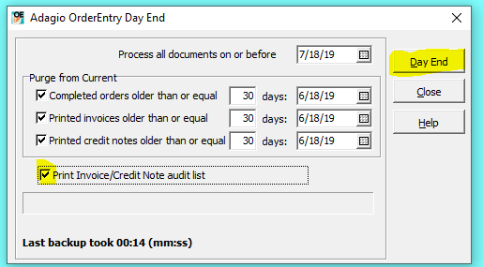

* Print Screen will appear, hit PRINT, then OK, YES, OK, NO, OK
* ORDERS 🡪 CREDITS NOTES tab 🡪 NEW  
  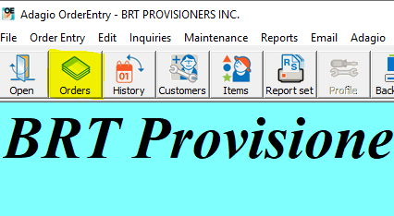

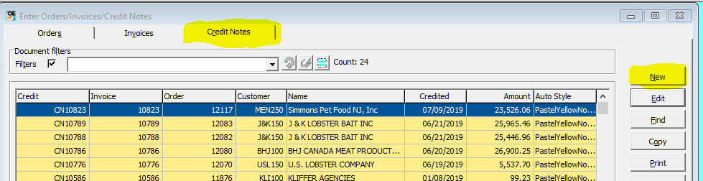

* Enter **INVOICE #** to be credited& OK

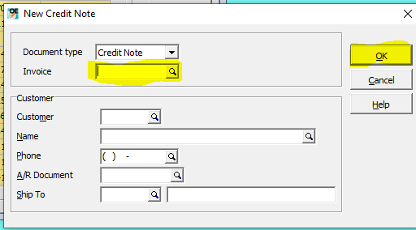

* Order Date = date of the invoice to be credited
* Click OK to accept CREDIT NOTE # (write down Credit Note # on P&L sheet beside original Sales Invoice #)
* Specifications – choose Invoice B/W CND or Invoice B/W (for USD currency)
* Clink PRINT / Click YES
* Email/Fax invoice to the customer

**NOTE – print 1 copy, and make a photocopy. One copy goes on top of current year file cabinet (2 hole clip board), the other copy stays with the order package